3.2 Website

3.2.1 Authentication

3.2.1.1 Login
Step 1: Access the FDA System Login Page
The user (Admin, Authority, or Super Admin) navigates to the FDA System administration portal at the official URL: fda-website.vercel.app .
The authentication page is displayed with a split-screen layout:
- Left panel: A branded gradient panel (blue to cyan) displaying the FDA System logo (water-drop icon), the headline 'Flood Monitoring System', and two feature cards: 'Real-time' and 'Safe Route'.
- Right panel: A centered login form area with the title 'Welcome Back' and a subtitle notice explaining this portal is for Admin, Authority, and Super Admin roles only.
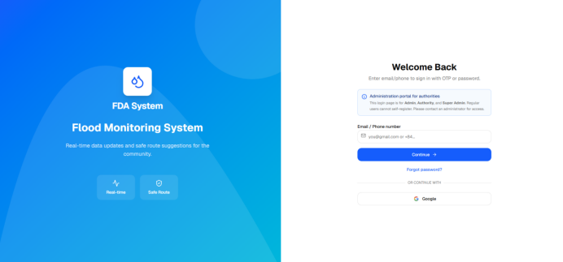
Figure 32: Login – Login Page Overview
Step 2: Enter Email or Phone Number
The user enters their registered email address or phone number into the 'Email / Phone number' input field.
The user then clicks 'Continue' to proceed.
The system calls the identifier-check API to determine the appropriate authentication method for the account.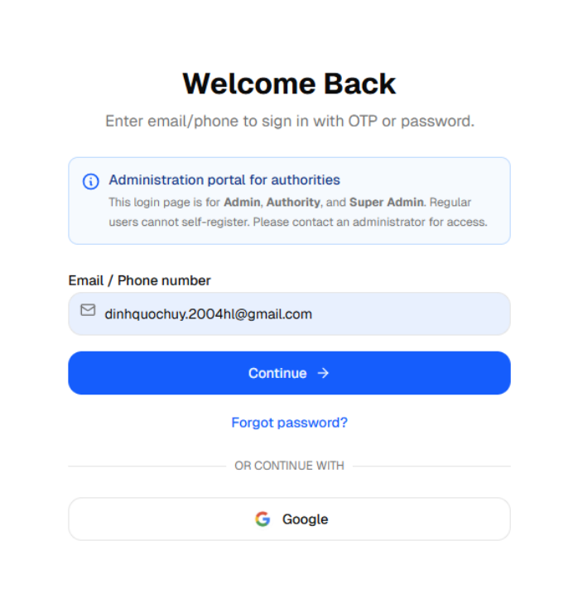
Figure 33: Login – Enter Identifier
Step 3.1: Login with Password
If the system determines the account uses password-based authentication, the form transitions to a password entry step:
- A text line displays: “Account: <user's email/phone>”
- A “Password” field appears with a lock icon on the left and a show/hide eye icon on the right.
- A “Forgot password?” link appears next to the password label.
- A “Sign In” → primary button and a “Back” secondary button are shown.

The user enters their password and clicks 'Sign In' to submit.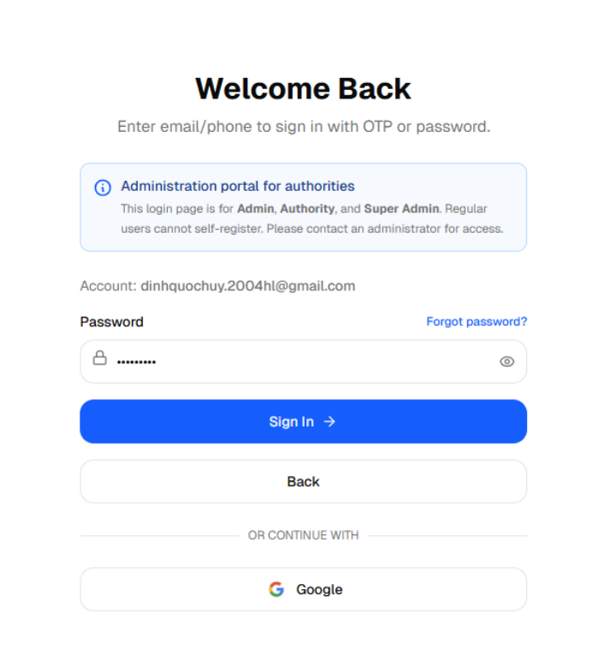
Figure 34: Login – Password Entry Form
Step 3.2: Login with OTP
If the system determines the account uses OTP-based authentication, the system automatically sends an OTP to the identifier and the form transitions to an OTP entry step:
- Header text shows: “OTP sent to: <identifier>”
- A 6-digit OTP input field is displayed.
- A countdown timer shows OTP expiry time (e.g., '4:59').
- “Sign In” primary button and two secondary buttons: “Change email/phone” and “Resend OTP”.

The user enters the 6-digit OTP received via email or phone and clicks “Sign In”.
Figure 35: Login – OTP Entry Form
Step 4: Successful Login – Redirect to Dashboard
Upon successful credential verification, the system:
Validates the user's role (SUPER_ADMIN, ADMIN, or AUTHORITY).
Redirects Admin/Super Admin roles to the '/admin' dashboard.
Redirects Authority roles to the '/authority' dashboard.
Displays a green toast notification: 'Signed in successfully!'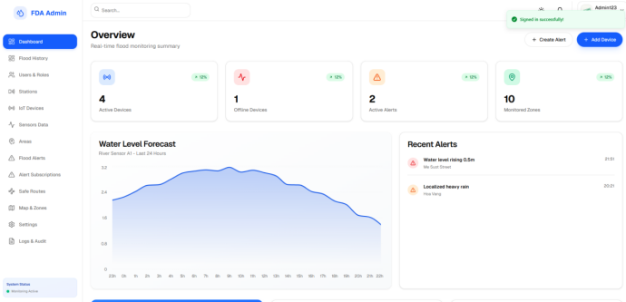
Figure 36: Login – Successful Login (Role-based Redirect)
Step 5: Login with Google Account
As an alternative, the user can click the 'Google' button below the form separator.
- The system calls the Google OAuth initialization API to generate the authorization URL.
- The browser is redirected to Google's sign-in page (accounts.google.com).
- The user selects their Google account and grants permission.
- Google redirects back to /auth/callback, completing authentication and redirecting to the role-based dashboard.
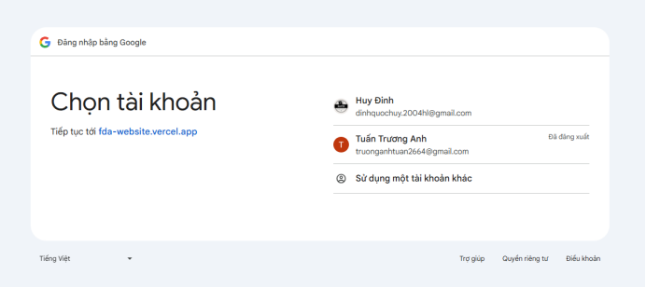
Figure 37: Login – Google OAuth Login Flow

3.2.1.2 Forgot and Reset Password
Step 1: Initiate Forgot Password from the Login Form
On the Login screen (identifier step or password step), the user clicks the 'Forgot password?' link.
The system requires the identifier field to contain a value before initiating forgot password.
If the identifier field is empty, a warning is shown: 'Please enter email or phone number.'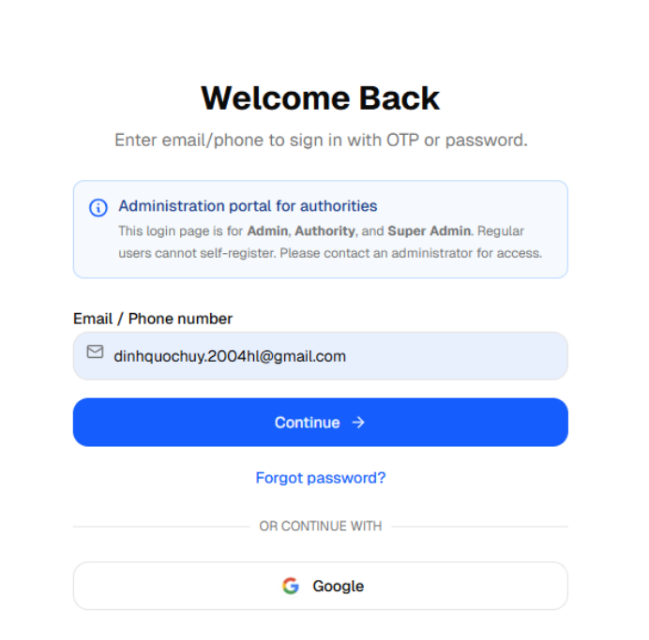
Figure 38: Forgot Password – Trigger Link Location
Step 2: OTP Sent for Password Reset
With a valid identifier entered, the system calls the OTP send API and transitions the form to OTP verification mode (FORGOT_PASSWORD mode).
A success toast is displayed: 'Password reset OTP has been sent!'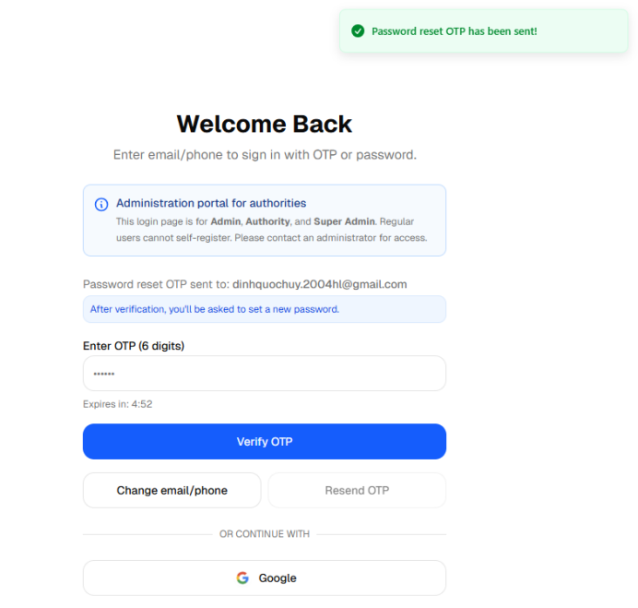
Figure 39: Forgot Password – OTP Sent Confirmation
Step 3: Enter and Verify OTP
The user retrieves the 6-digit OTP from their email or phone.
The user types the OTP into the input field and clicks 'Verify OTP'.
If the OTP is fewer than 6 digits: yellow toast 'OTP must be 6 digits.'
If the OTP has expired, the 'Resend OTP' button becomes clickable to request a new code.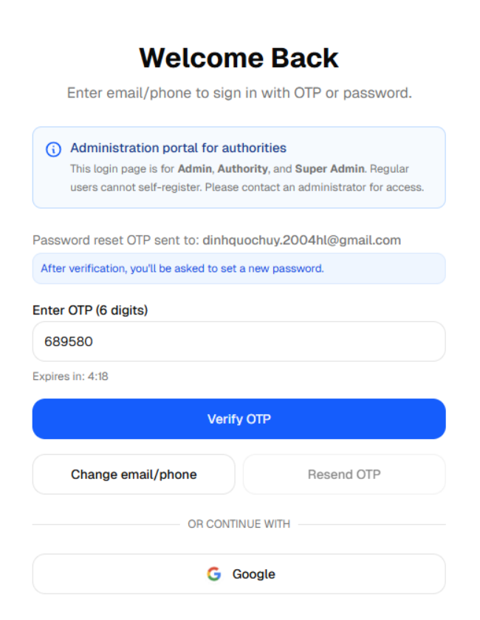
Figure 40: Forgot Password – OTP Input Interaction
Step 4: Set a New Password
Upon successful OTP verification in FORGOT_PASSWORD mode, the system logs the user in and automatically opens the 'Set a new password' modal over the dashboard.
Inside the dialog, the user enters:
- New Password – must satisfy all five security requirements.
- Confirm Password – must match the new password exactly.
Requirements are shown as a real-time checklist:
- At least 8 characters
- Contains uppercase (A-Z)
- Contains lowercase (a-z)
- Contains a number (0-9)
- Contains a special character (!@#$...)

A password match indicator also appears when the user types in the Confirm Password field.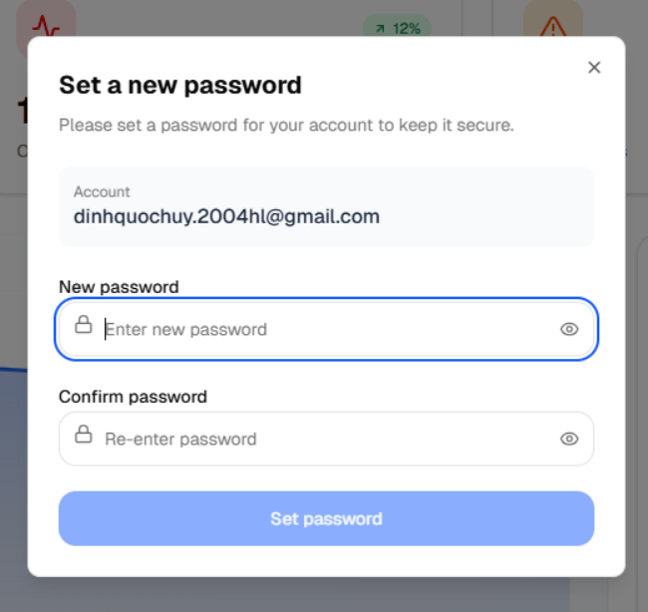
Figure 41: Forgot Password – Set New Password Modal

Step 5: Confirm Reset and Log In Normally
After the user clicks 'Set password' and the API confirms success:
- Green toast: 'Password reset successful!'
- The modal closes automatically.
- The user is fully logged in and can use the system normally.

For future logins, the user signs in with their email and the newly set password (password-based flow).
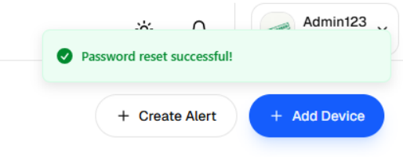
Figure 42: Forgot Password – Password Reset Successful

3.2.2 Profile Management

3.2.1.1 Information Tab
Step 1: Open the Profile Pannel
- Click on your avatar or display name at the top-right corner of the dashboard.
- From the dropdown menu, select "Profile" to open the profile modal.
- The panel opens on the Information tab by default.

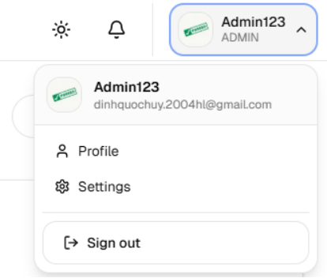
Figure 43: View Profile

Step 2: View Account Information
The Information tab displays the following details:
- Full Name - Your display name. This field can be edited.
- Email - The email address associated with your account. This field cannot be changed.
- Phone Number - Your phone number registered to the account (view only on this tab; updates are done in the Phone Number tab).
- Provider / Status - The login method used (e.g., local or Google) and the current account status (e.g., Active).
- Verification - Shows whether your Email and Phone Number have been verified.
- Roles - The role(s) assigned to your account (e.g., User, Admin, Authority, Super Admin).
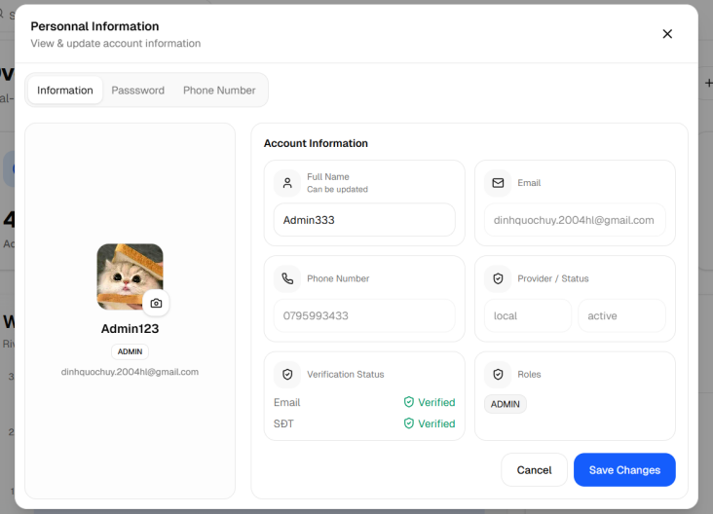
Figure 44: View account profile information

Step 3: Update Your Full Name
- Click inside the Full Name field and type your new name.
- The name entered here will be displayed throughout the system.
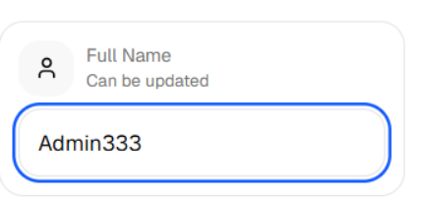
Figure 45: View account profile information
Step 4: Update Your Profile Picture
- On the left side of the panel, click the small camera icon located at the bottom-right corner of your avatar.
- A file picker will open. Select an image file from your device (JPG, PNG, etc.).
- The new image will appear as a preview immediately. It will only be saved after you click Save.
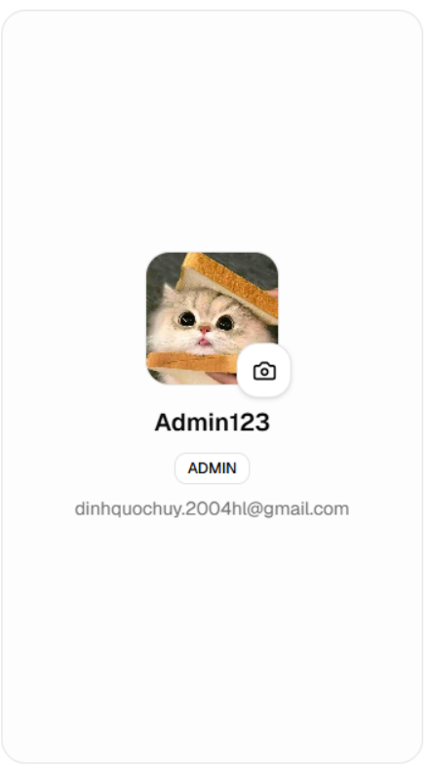
Figure 46: View account profile information

Step 5: Save or Cancel Changes
After making your changes, click the "Save Changes" button at the bottom-right of the form.
- Success - The profile is updated and the panel closes automatically.
- Cancel - Click "Cancel" to discard all unsaved changes and restore the original values.
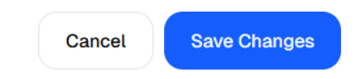
Figure 47: View account profile information

3.2.1.2 Password Tab
Step 1: Switch to the Password Tab
- Inside the profile panel, click the "Password" tab at the top of the right section.
- The Change Password form will appear.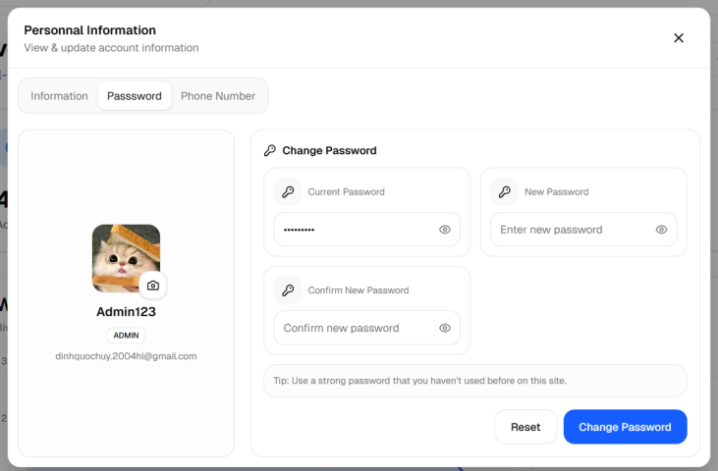
Figure 48: View profile

Step 2: Fill in the Password Fields
The form contains three required fields:
- Current Password - Enter the password you are currently using to log in. Use the eye icon on the right of the field to show or hide the characters.
- New Password - Enter the new password you want to set. Use the eye icon to show or hide the characters.
- Confirm New Password - Re-enter the new password to confirm it matches. Use the eye icon to show or hide the characters.
Note: The new password and the Confirm New Password must be exactly the same. If they do not match, the system will display an error and prevent the

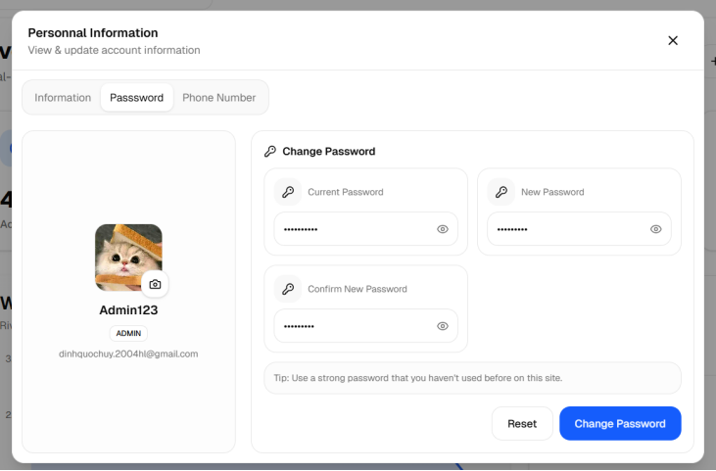
Figure 49: View profile
Step 3: Submit the Password Change
After filling in all three fields, click the “Change Password” button at the bottom-right.
- Success - The password is updated and the panel closes automatically. You will need to use the new password the next time you log in.
- Error (fields empty) - If any field is left blank, a message will appear: "Please fill in all fields."
- Error (passwords do not match) - If the New Password and Confirm New Password do not match, a message will appear: "Confirm password does not match."
- Error (wrong current password) - If the current password entered is incorrect, the system will show an error from the server.
Click “Reset” to clear all three fields and start over without closing the panel

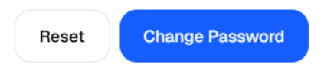
Figure 50: Submit the Password Change

3.2.1.3 Phone Number Tab
Step 1: Switch to the Phone Number Tab
- Inside the profile panel, click the "Phone Number" tab at the top of the right section.
- The Update Phone Number form will appear.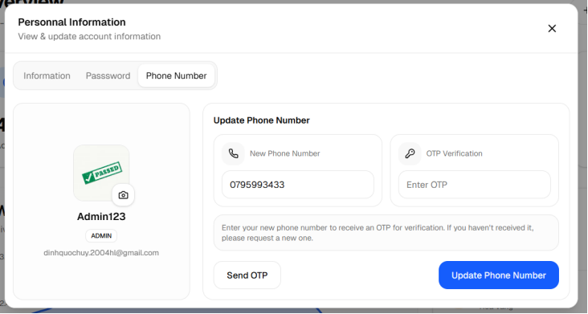
Figure 51: Phone Number Tab
Step 2: Enter the New Phone Number
- In the "New Phone Number" field, type the phone number you want to link to your account.
- Use the international format if applicable (e.g., +84901234567 for a Vietnamese number).
- Make sure the number is correct, as the OTP verification code will be sent to this number.
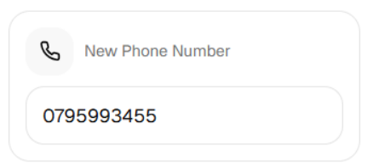
Figure 52: Enter the New Phone Number
Step 3: Request an OTP Code
Click the “Send OTP” button on the left side of the action bar.
- Success - An OTP code will be sent as an SMS to the phone number you entered. A countdown timer will appear, showing how many seconds remain before the OTP expires.
- Error (empty field) - If the phone number field is empty, the system will show a message: "Please enter a phone number."
- Error (invalid number) - If the number is not valid or cannot receive SMS, the system will display an error.
Note: The OTP code is valid for a limited time (shown by the countdown timer). If it expires before you enter it, click "Send OTP" again to receive a new code.

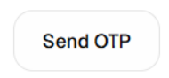
Figure 53: “Send OTP” button

Step 4: Enter the OTP Code
- Check your phone for the SMS message containing the OTP code.
- Type the 6-digit OTP code into the “OTP Verification” field.
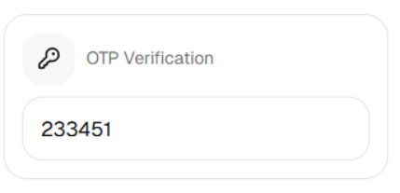
Figure 54: Enter the OTP Code

Step 5: Confirm the Update
Click the "Update" button on the right side of the action bar.
- Success - The phone number is updated and the panel closes automatically. Your new phone number now appears on the Information tab.
- Error (OTP expired or wrong) - If the code is incorrect or has expired, an error message will appear. Click "Send OTP" again to request a new code.
- Error (fields empty) - If either field is empty, the system will show: "Please enter your phone number and OTP."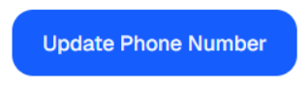
Figure 55: Confirm the Update

3.2.3 User Management

3.2.3.1 View and Search Users
Step 1: Navigate to the Users & Roles Tab
- After logging in with the Super Admin account, the system redirects to the Admin Dashboard.
- On the left-hand sidebar, click on "Users & Roles" to open the user management section
- The main area now displays a data table listing all registered users in the system.
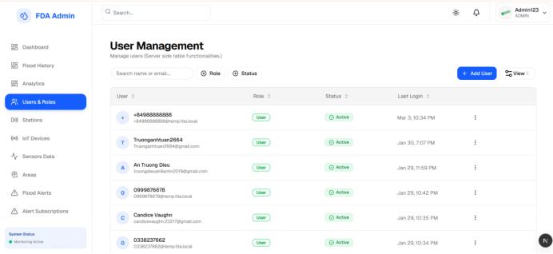
Figure 56: View User List

Step 2: Understand the User Table
The table presents the following columns for each user account:
- User – Displays the user's full name and email address, along with an avatar initial for quick recognition.
- Role – Shows the assigned role(s) of the user, displayed as a colored badge:
  - Super Admin – Highest-level administrator
  - Admin – System administrator
  - Authority – Government/authority-level account
  - User – Standard end-user account
- Status – Shows the current account status:
  - Active – The account is in normal use
  - Banned – The account has been blocked from logging in
  - Inactive – The account exists but is not currently active

- Last Login – The most recent date and time the user logged into the system.
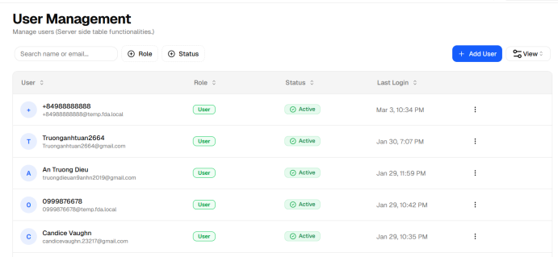
Figure 57: View User List
Step 3: Search and Filter the User List
The toolbar above the table provides multiple ways to find specific users quickly:

- Search box – Type a name or email address to filter results as you type. Results update automatically.
- Role filter – Click the "Role" dropdown to show only users who have a specific role (e.g., Admin, Authority, User).
- Status filter – Click the "Status" dropdown to display only users with a chosen account status (e.g., Active, Banned).
Multiple filters can be combined at the same time for a more refined search
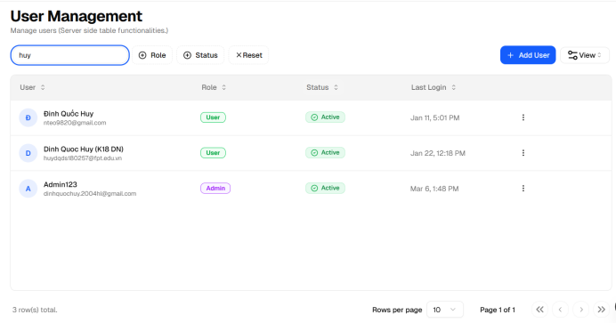
Figure 58: Search User

3.2.3.2 Create a New User
Step 1: Open the Create User Form
- In the User Management page, click the "+ Add User" button located at the top-right of the user table toolbar.
- A dialog box titled "Create New User" will appear on the screen.
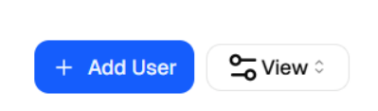
Figure 59: Add User
Step 2: Fill in User Information
The form contains the following fields (fields marked with * are required):
- Email * – Enter a valid email address for the new user (e.g., user@example.com). This email will be used for login and system notifications.
- Password * – Set an initial password for the account. The password must be at least 6 characters long.
- Full Name * – Enter the user's full name as it will be displayed in the system.
- Phone Number (optional) – Enter a 10–11 digit Vietnamese phone number. This field is not required but can be provided for contact purposes.
- Status – Select the initial account status from the dropdown:
- Active – The user can log in immediately after the account is created.
- Inactive – The account is created but the user cannot log in yet.
- Banned – The account is created in a blocked state.
- Role * – Choose the role assigned to this user. Available roles are:
- User – Standard citizen/end-user (default)
- Admin – System administrator
- Super Admin – Highest-level administrator
- · Authority – Government or regulatory authority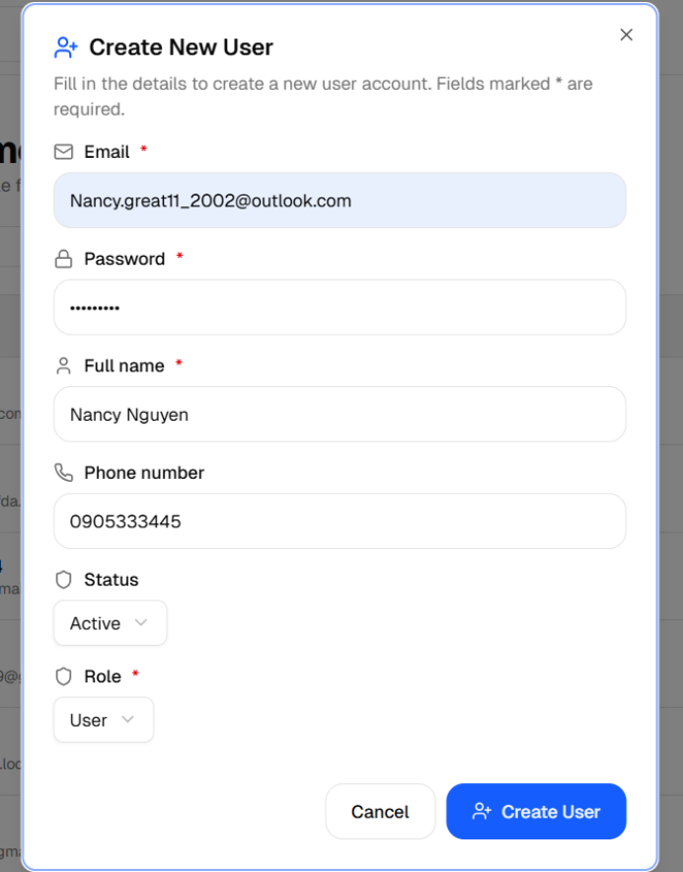
Figure 60: View Create User Form
Step 3: Submit the Form
After filling in all required fields, click the "Create User" button at the bottom of the dialog.

- If all information is valid, the system will create the account and display a success notification: "User created successfully!" The new user will immediately appear in the user table.
- If any required field is missing or invalid (e.g., incorrect email format, password too short, invalid phone number), the system will highlight the problematic field in red and display a clear error message asking you to correct it.

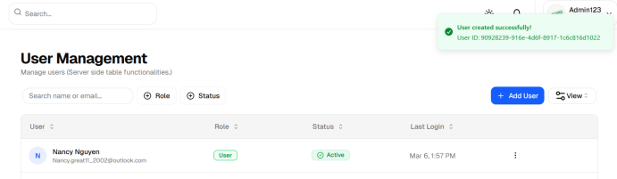
Figure 61: Submit the Form

3.2.3.3 Edit an Existing User
Note: Only user accounts that were created by an admin can be edited. Accounts registered directly by users through the app cannot be edited from this interface.

Step 1: Open User Management Module
- In the user table, locate the user account you want to update.
- Click the ⋮ (three-dot menu) icon located at the far-right of that user's row.
- A small dropdown menu will appear showing the available actions.

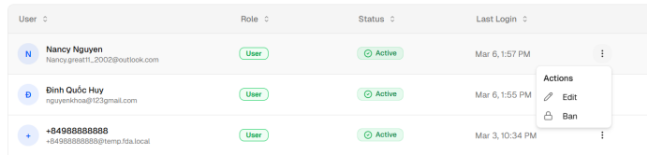
Figure 62: Edit User
Step 2: Select “Edit”
- Click "Edit" from the dropdown menu.
- An "Edit User" dialog box will appear, pre-filled with the user's current information.
- If the selected user was not created by an admin, the Edit option will be disabled (grayed out), and an error toast will appear indicating that only admin-created accounts can be edited.
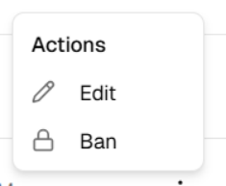
Figure 63: Edit User
Step 3: Update User information
This edit form contains the following fields:
- Email – This field is shown for reference only and cannot be changed.
- Full Name * – Update the user's display name.
- Phone Number (optional) – Update or add a phone number (10–11 digits).
- Status * – Change the account's current status (Active / Inactive / Banned).
- Role * – Change the user's assigned role. Use the radio buttons to select one of the available roles:
  - User
  - Admin
  - Super Admin
  - Authority
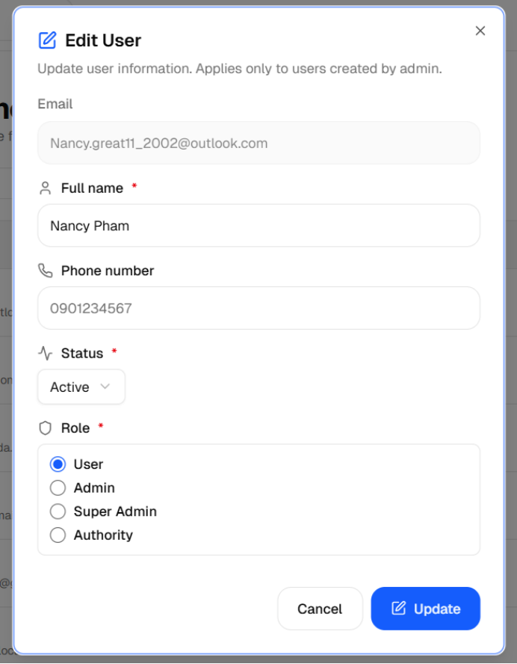
Figure 64: Update User information
Step 4: Save the changes
Click the "Update" button to save all changes.

- If the update is successful, a notification will appear: "User updated successfully!" The table will automatically refresh to reflect the changes.
- If an error occurs (e.g., a required field is empty or the phone number is in the wrong format), the system will display an error message next to the relevant filed.
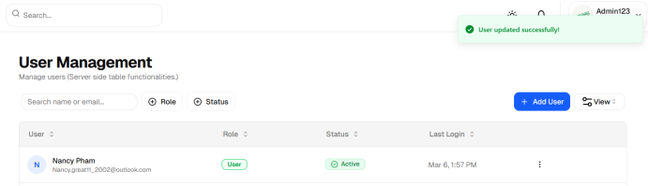
Figure 65: Save the changes

3.2.3.4 Ban/ Unban a User
This action lets the Super Admin immediately block a user from logging into the system, or restore access to a previously banned account.

Step 1: Open the Actions Menu
- In the user table, locate the user account you want to ban or unban.
- Click the ⋮ (three-dot menu) icon at the right end of that user's row.
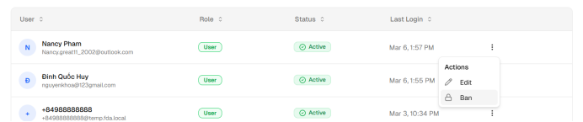
Figure 66: Ban User
Step 2: Select "Ban" or "Unban"
- If the user's current status is Active or Inactive, the menu will show "Ban".
- If the user's current status is already Banned, the menu will show "Unban".
Click the appropriate option.
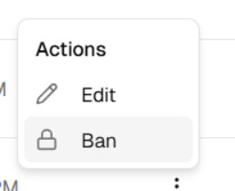
Figure 67: Select "Ban" or "Unban"
Step 3: Confirm the Action
- A confirmation dialog will appear, showing:
  - · The email address of the user about to be banned or unbanned.
  - · A short explanation of what the action does:
  - · "User will not be able to sign in after being banned."
  - · "User will be able to sign in after being unbanned."

- Click "Ban user" (or "Unban user") to proceed, or click "Cancel" to go back without making any changes.
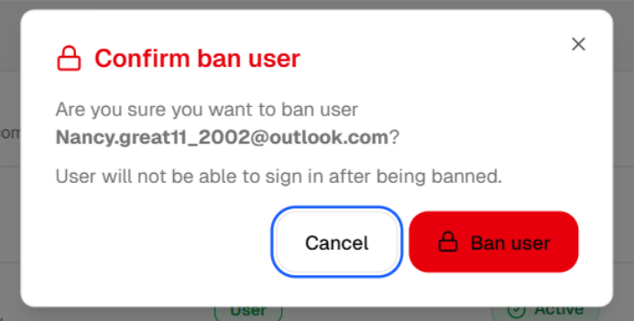
Figure 68: Confirm the Action

Step 4: Outcome after Ban/ Unban
- If the action is successful, a confirmation toast message will appear:
- · "User [email] has been banned."
- · "User [email] has been unbanned."
- · The user's Status badge in the table will immediately update to reflect the new state.
- · A banned user will be immediately prevented from logging into the system until the Super Admin unbans their account.
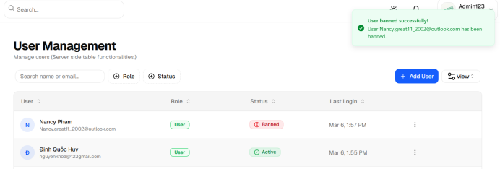
Figure 69: Outcome after Ban/ Unban

3.2.4 Station Management

3.2.4.1 View and Search Stations
Step 1: Navigate to the Station Management Page
- After logging in, click on "Stations" in the left-hand sidebar of the Admin Dashboard.
- The main area displays a table listing all monitoring stations registered in the system.

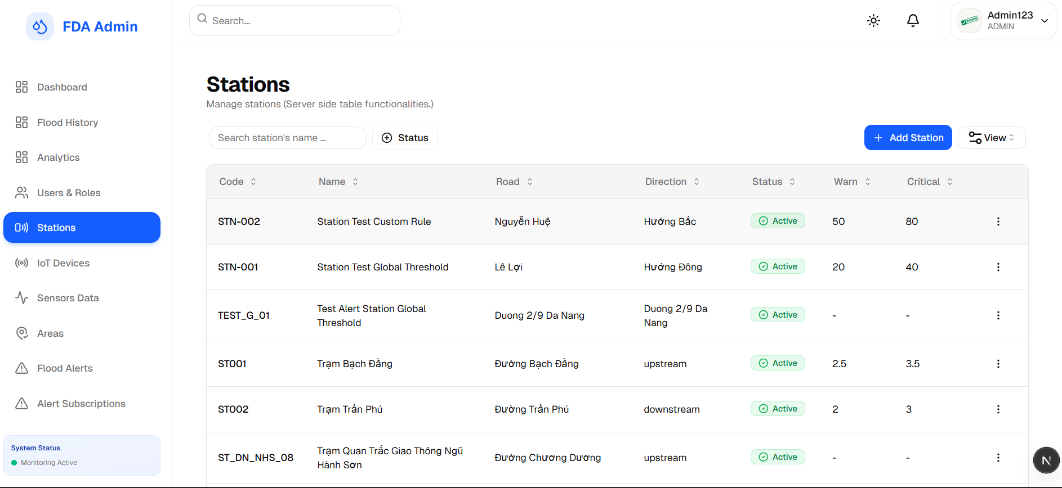
Figure 70: Station Management
Step 2: View Station Table
Each row in the table represents one monitoring station with the following information:
- Code - The unique identifier code of the station (e.g., ST_DN_DRAGON_01). Used to quickly reference a station in the system.
- Name - The full display name of the station (e.g., Dragon Bridge Station).
- Road - The name of the road or area where the station is located.
- Direction - The water flow direction relative to the station location:
  - Upstream - The station monitors water flowing toward the area.
  - Downstream - The station monitors water flowing away from the area.
  - Road Section - The station is placed at a specific road section.
- Status - The current operating status of the station, shown as a colored badge:
  - Active (Green) - The station is running normally and sending data.
  - Maintenance (Yellow) - The station is temporarily offline for maintenance work.
  - Offline (Red) - The station is not responding or has stopped sending data.
- Warn (Warning Threshold) - The water level (in meters) at which a Warning alert is triggered.
- Critical (Critical Threshold) - The water level (in meters) at which a Critical alert is triggered.

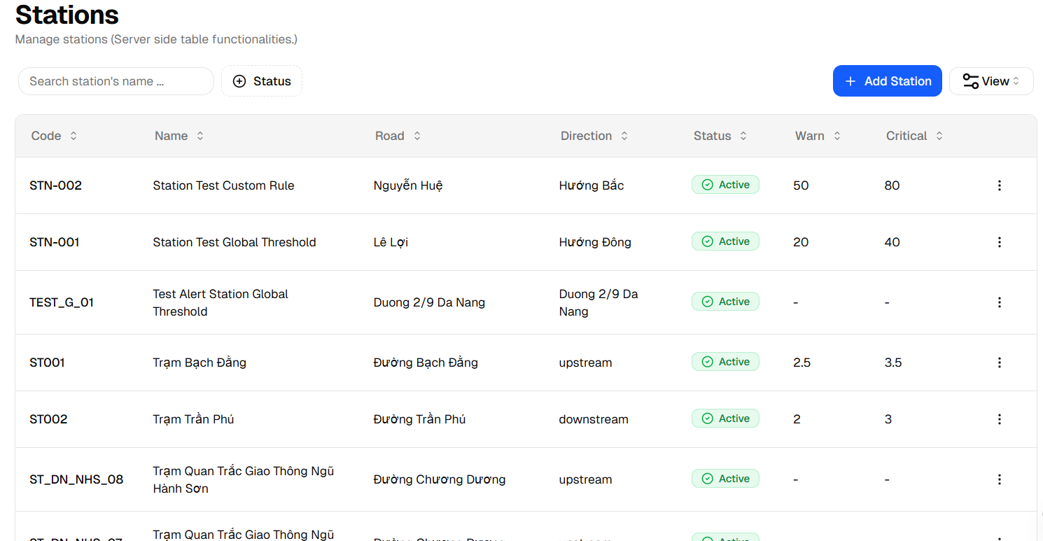
Figure 71: View Station Table
Step 3: Search and Filter Stations
The toolbar above the table provides tools to quickly find a specific station:
- Search by Name - Type part of the station name in the search box. The table filters results automatically as you type.
- Status filter - Click the "Status" dropdown to show only stations with a specific status. You can select multiple statuses at the same time (e.g., show both Active and Maintenance stations at once).
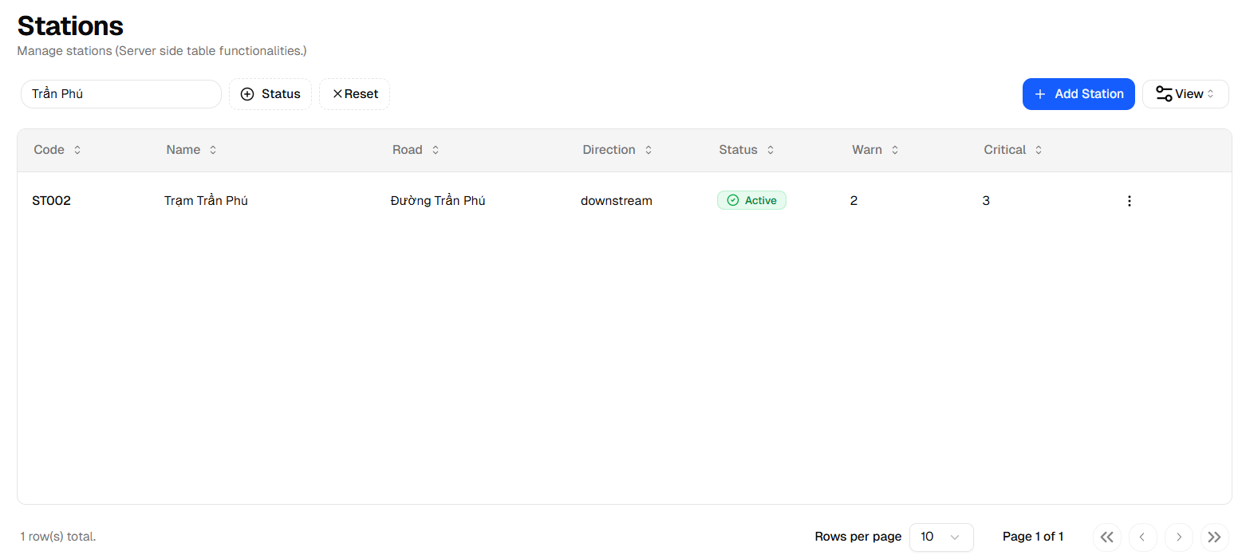
Figure 72: Search and Filter Stations
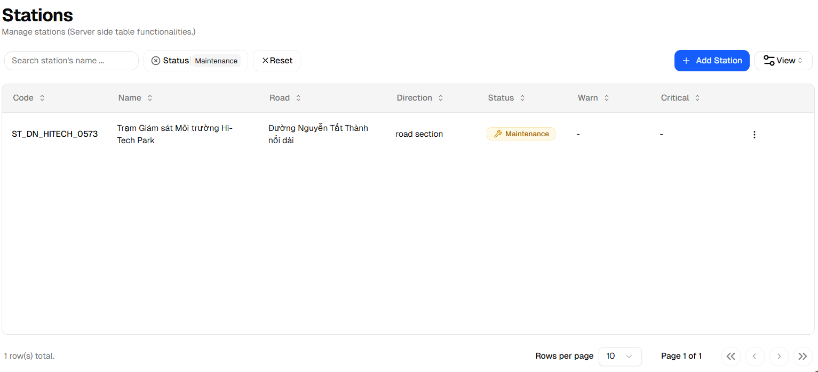
Figure 73: Filter Station

3.2.4.2 Add a New Station
Step 1: Open the Add Station Form
- On the Station Management page, click the "+ Add Station" button at the top-right of the toolbar.
- A dialog box titled "Create New Station" will appear on the screen.

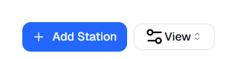
Figure 74: Add Station Button

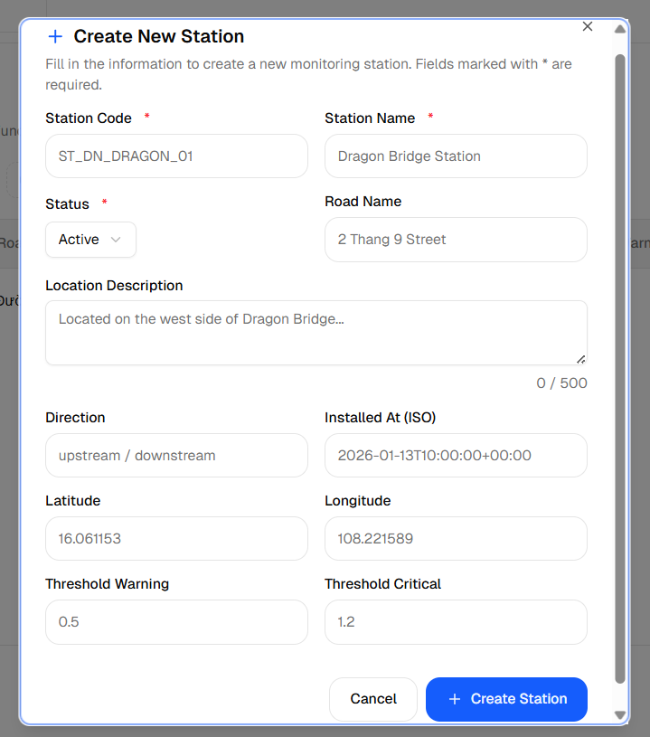
Figure 75: Add Station Form
Step 2: Fill in Basic Information
The form is divided into several sections. Start with the basic details (fields marked with * are required):
- Station Code * - Enter a unique code to identify this station. Use a consistent naming pattern (e.g., ST_DN_DRAGON_01 for Station - Da Nang - Dragon Bridge - Unit 01). Must be at least 2 characters.
- Station Name * - Enter a descriptive name for the station (e.g., Dragon Bridge Station). Must be at least 2 characters.
- Status * - Select the station's current operating state from the dropdown:
  - Active - The station is installed and operational.
  - Offline - The station is not currently sending data.
  - Maintenance - The station is undergoing maintenance.
- Road Name - Enter the name of the road or street where the station is placed (e.g., 2 Thang 9 Street).
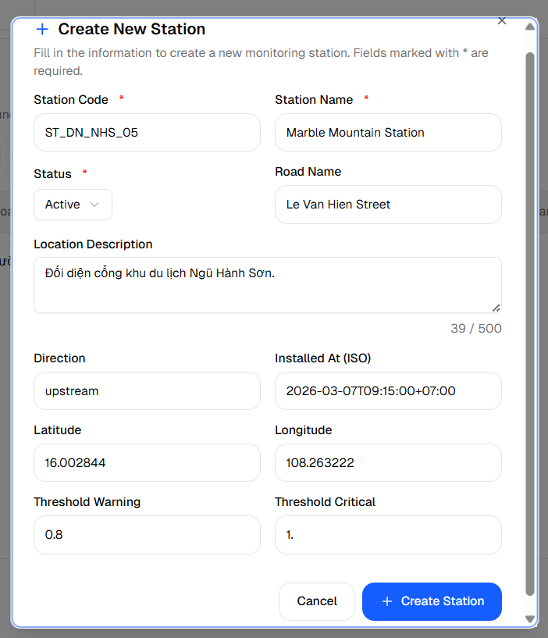
Figure 76: Fill in Basic Information

Step 3: Add Location Details
Provide more information about where the station is physically located:
- Location Description - Write a short description of the installation spot (e.g., "Located on the west side of Dragon Bridge, near the riverbank"). Maximum 500 characters.
- Direction - Describe the water flow direction at this station (e.g., upstream, downstream, or road section).
- Installed At - Enter the date and time when the station was physically installed. Use the standard date-time format shown in the placeholder.
- Latitude - Enter the geographic latitude coordinate of the station (e.g., 16.061153). Must be between -90 and 90.
- Longitude - Enter the geographic longitude coordinate of the station (e.g., 108.221589). Must be between -180 and 180.
Note: Latitude and Longitude are used to show the station on the map. If you do not know the exact coordinates, you can look them up using Google Maps.


Figure 77: Add Location Details

Step 4: Set Alert Thresholds
Alert thresholds define the water levels that trigger flood warnings for this station:
- Threshold Warning - Set the water level (in meters) at which a Warning alert is sent (e.g., 0.5). When the measured water level reaches this value, the system will notify relevant users.
- Threshold Critical - Set the water level (in meters) at which a Critical alert is sent (e.g., 1.2). This represents a more serious flooding condition that requires urgent attention.
Note: The Critical threshold should always be set higher than the Warning threshold to ensure alerts are triggered in the correct order.


Figure 78: View Technical Chart
Step 5: Save the New Station
After filling in all required fields, click the "Create Station" button at the bottom of the form.
- Success - A notification appears: "Station created successfully!" The new station will immediately appear in the station table.
- Validation error - If a required field is missing or a value is out of range (e.g., invalid coordinates), the field will be highlighted red with an error message. Correct the error and try
Click "Cancel" to close the form without saving anything.
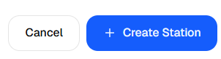
Figure 79: Save the New Station

3.2.4.3 Update a Station
Step 1: Open the Actions Menu
- In the station table, locate the station you want to update.
- Click the three-dot menu icon (kebab menu) at the far-right of that station's row.
- A dropdown menu will appear with two options: Update and Delete.

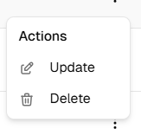
Figure 80: Open the Actions Menu
Step 2: Select “Update”
- Click "Update" from the dropdown menu.
- An "Edit Station" dialog box will appear, pre-filled with the station's existing information.
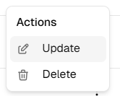
Figure 81: Click "Update"
Step 3: Modify the Station Information
The edit form contains the same fields as the create form. You can update any of the following:
- Station Code * - Change the station's unique code if needed.
- Station Name * - Update the display name of the station.
- Status * - Change the operating status (Active / Offline / Maintenance).
- Road Name - Update the road name.
- Location Description - Update the written description of the location.
- Direction - Update the water flow direction.
- Installed At - Correct or update the installation date.
- Latitude / Longitude - Update the geographic coordinates.
- Threshold Warning / Threshold Critical - Adjust the flood alert thresholds.
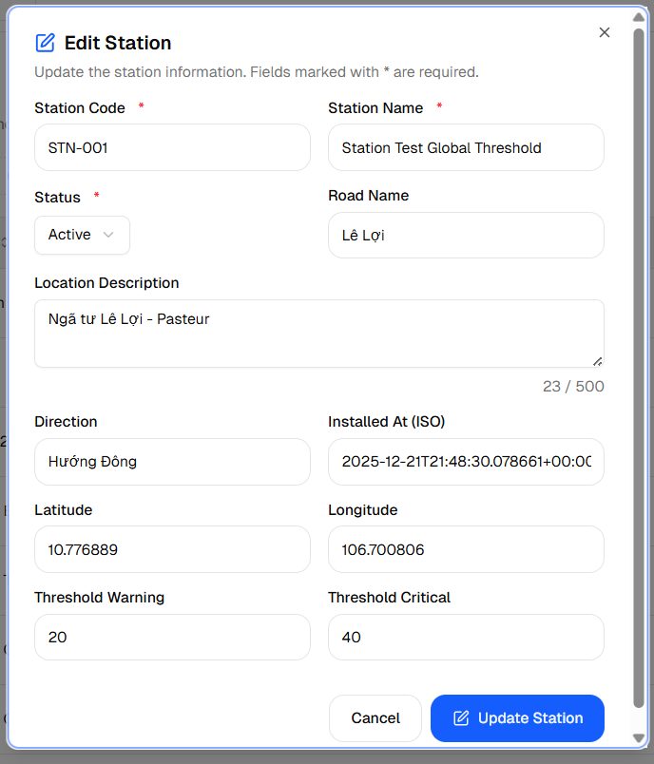
Figure 82: Modify the Station
Step 4: Save the Changes
After making all desired changes, click the "Update Station" button.
- Success - A notification appears: "Station updated successfully!" The table will automatically show the updated information.
- Validation error - If a required field is empty or a value is invalid, the field is highlighted in red. Correct it and click "Update Station" again.
Click "Cancel" to close the dialog without saving any changes.
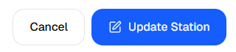
Figure 83: Save the Changes

3.2.4.4 Delete a Station
Step 1: Open the Actions Menu
- In the station table, locate the station you want to remove.
- Click the three-dot menu icon at the far-right of that station's row.
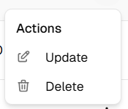
Figure 84: Delete a Station
Step 2: Select “Delete”
- Click "Delete" from the dropdown menu.
- A confirmation dialog will appear asking you to confirm the action.
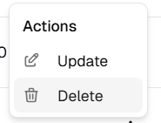
Figure 85: Select “Delete”
Step 3: Confirm the Deletion
Read the confirmation message carefully to ensure you have selected the correct station.
- Confirm - Click "Confirm" (or "Continue") to permanently delete the station. The station will be removed from the table immediately.
- Cancel - Click "Cancel" to go back without deleting anything.
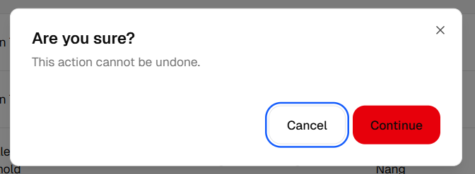
Figure 86: Deletion

3.2.5 Alert and Notification Management

3.2.5.1 Alert Message Template Management

3.2.5.2 Notification Management

3.2.6 Payment and Subscription Plan Management

3.2.6.1 Subscription Plan

3.2.6.2 View Payment Records

3.2.6.3 Handle customer Disputes

3.2.7 Flood Map Realtime

3.2.7.1 View Flood Map Realtime

3.2.7.2 View Flood Condition by Sensor Stations

3.2.7.3 Filter and Toggle Flood Map

3.2.8 AI-based Flood Prediction

3.2.8.1 View AI-based Flood Prediction

3.2.8.2 Compare AI Predictions with Actual Data

3.2.8.3 Identify High-risk Flood Zones (AI)

3.2.9 Community Management

3.2.9.1 View Community Flood Report

3.2.9.2 Compare AI Predictions with Actual Data

3.2.9.3 Identify High-risk Flood Zones (AI)

3.2.10 Flood History and Trends

3.2.10.1 View Flood History

3.2.10.2 Flood Trends

